**1. To verify that www.sharekhan.com is launched in browser as below**

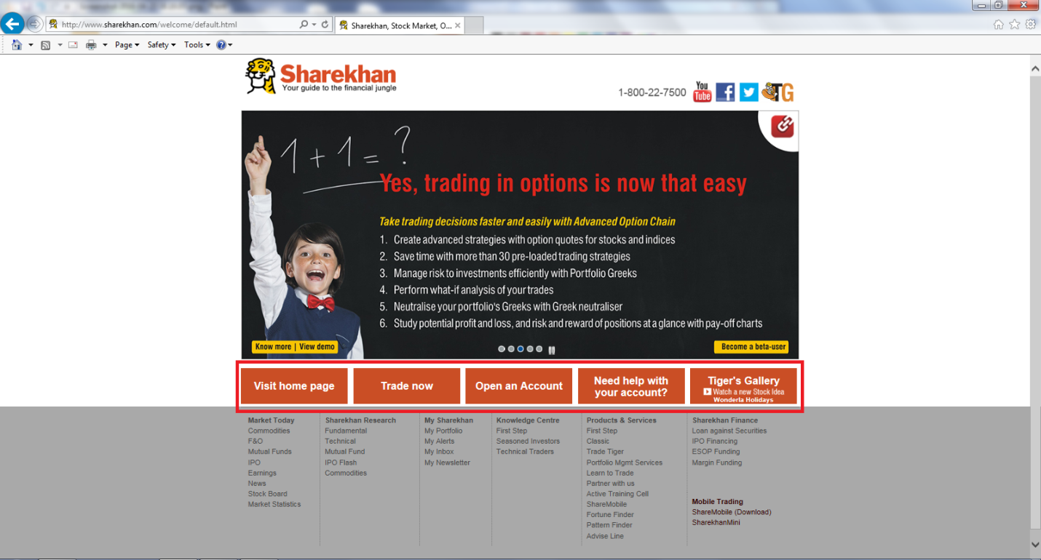

**Steps-**

* Launch Internet Explorer
* Type www.sharekhan.com in Address bar
* Close the web page after verification

**Verification-**

"**Visit home page**", "**Trade now**", "**Open an Account**", "**Need help with your account?**", "**Tiger's Gallery**" buttons marked in RED in above screenshot

**2. To verify that when user clicks on "Visit home page" button, below page is launched as below-**

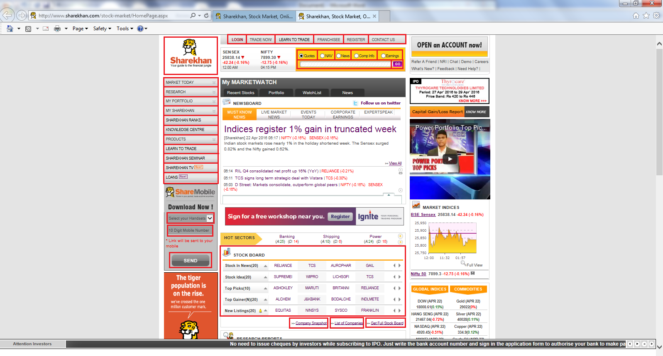

**Steps-**

* Launch Internet Explorer
* Type www.sharekhan.com in Address bar
* Click "Visit home page" button (As shown in test case 1)
* Close the web page after verification

**Verification as indicated below-**

|  |  |
| --- | --- |
| Sharekhan logo |  |
| Menu links (ALL) |  |
| Radio buttons (ALL) |  |
| Search text box |  |
| "GO" button |  |
| Left side menu (ALL) |  |
| Select drop down box |  |
| Mobile no text box |  |
| "SEND" button |  |
| "STOCK BOARD" table (Labels in First column) |  |
| Links |  |

**3. To verify that when user clicks on Menu links like "LOGIN", "TRADE NOW","LEARN TO TRADE", "FRANCHISEE", "REGISTER", "CONTACT US" the respective page/popup box is launched-**

**Steps-**

* Launch Internet Explorer
* Type www.sharekhan.com in Address bar
* Click "Visit home page" button (As shown in test case 1)
* Click "LOGIN"
* Click "TRADE NOW"
* Click "LEARN TO TRADE". Go back to previous page after verification.
* Click "FRANCHISEE". Go back to previous page after verification.
* Click "REGISTER"
* Click "CONTACT US". Close the web page after verification

**Verification as marked in RED below-**

|  |  |
| --- | --- |
| "LOGIN" popup box  - Menu items like "Online Trading User", "Offline Trading User" & "Registered User" with default menu item selected i.e "Online Trading User". |  |
| "TRADE NOW" popup box  - Links in popup like "Classic", "Commodity", "IPO", "Mutual Fund", "Mini (Low Bandwidth)" |  |
| "REGISTER" popup box  - Email ID text box  - Password text box  - Confirm Password text box  - Mobile No. text box  - City Code text box  - Landline No text box  -Captcha Code text box (Empty and with code)  - Terms and Conditions check box  - Buttons like "SUBMIT" and "RESET" |  |

"LEARN TO TRADE" web page (Verification- "Online-Trading Academy" title, "Pin Code" text box & "GO" button)

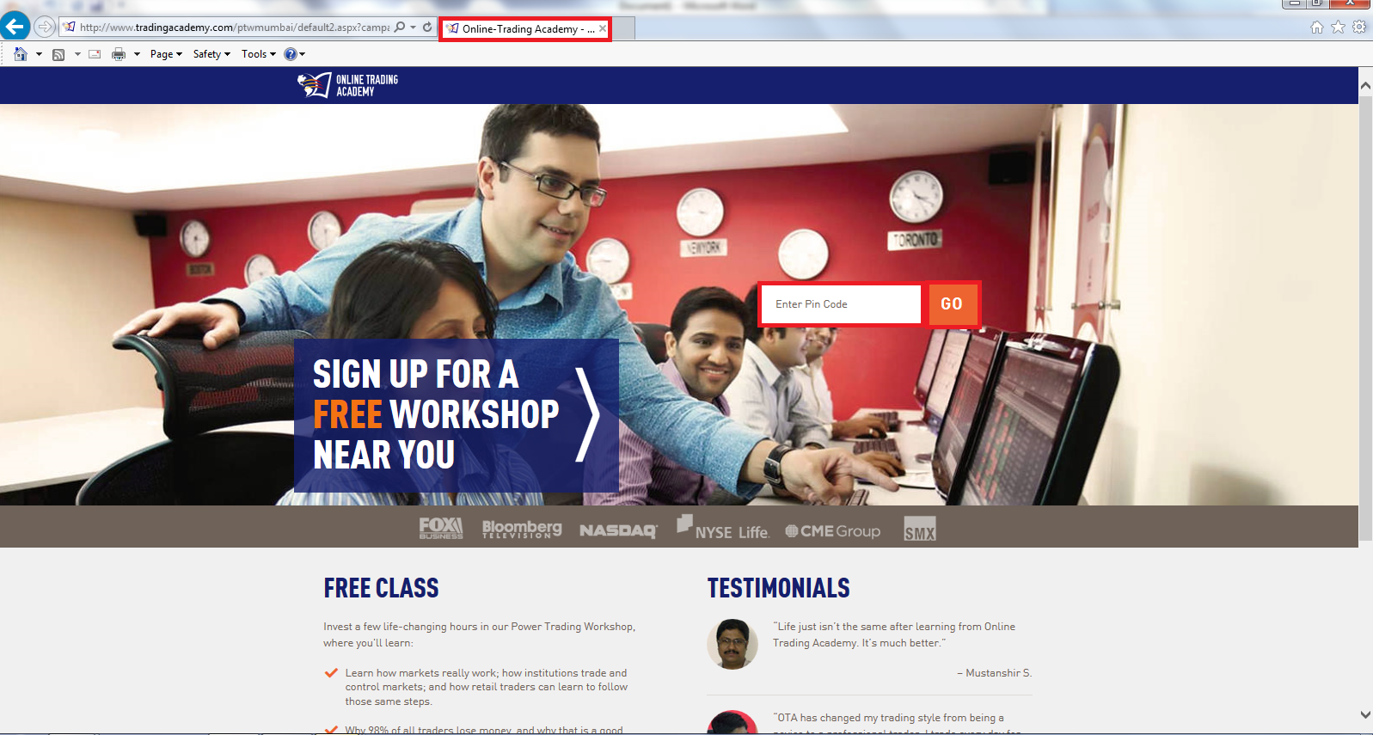

" FRANCHISEE" web page (Verification- "Sharekhan-Trade Online" title, Tabs like "WHY SHAREKHAN", "HOW TO PARTNER" & "PRODUCT RANGE", Text boxes like "Name", "Mobile", "Pincode", Dropdown like "Nearest Share Shop" and button like "SIGN UP")

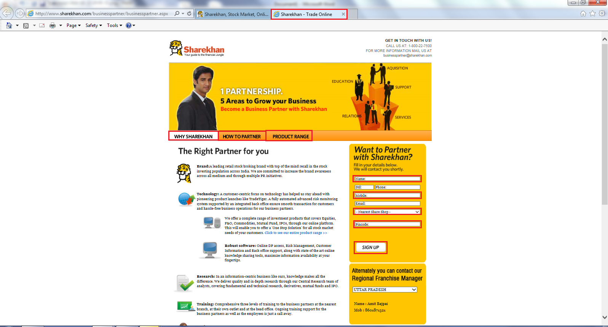

"CONTACT US" web page (Verification- "Sharekhan-Contact Us" title, Tabs like "Contact Details", "Branch Locator", "Leave us a query", "FAQ" & "Live Chat", Heading like "CONTACT US" & "REGISTERED OFFICE")

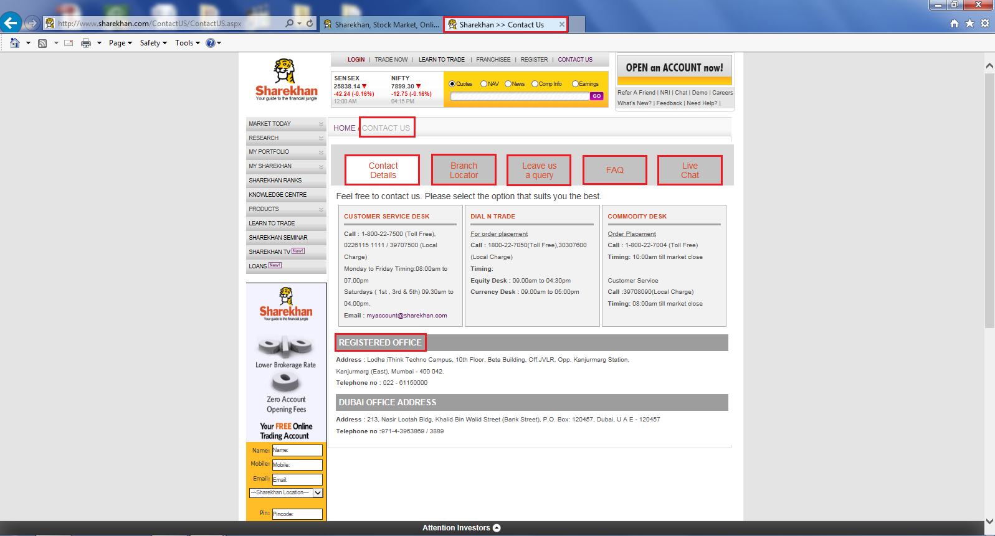

4. **To verify that when user clicks on Menu link "LOGIN" options(Online Trading User, Offline Trading User & Registered User), corresponding popup/web page appears**

**Steps-**

* Launch Internet Explorer
* Type www.sharekhan.com in Address bar
* Click "Visit home page" button (As shown in test case 1)
* Click "LOGIN->Online Trading User"
* Click "LOGIN->Offline Trading User"
* Click "LOGIN->Registered User". Close the web page after verification

**Verification as marked in RED below-**

|  |  |
| --- | --- |
| - Login ID text box  - Membership Password text box  - Trading Password text box  - Go To drop down  - Login button  - Links like "Change in Profile", "Forgot Password/Account Locked" |  |
| - Offline Client Code text box  - Password text box  - Login now button |  |
| - Your Username/E-mail text box  - Your Password text box  - Where would you like to go? dropdown  - Login button |  |

**5. To verify that when user clicks on Menu link "TRADE NOW" options [Classic, Commodity, IPO, Mutual Fund, Mini (Low Bandwidth)] appropriate web page or popup appears**

**Steps-**

* Launch Internet Explorer
* Type www.sharekhan.com in Address bar
* Click "Visit home page" button (As shown in test case 1)
* Click "TRADE NOW->Classic". Go back to previous page after verification.
* Click "TRADE NOW->Commodity". Go back to previous page after verification.
* Click "TRADE NOW->IPO". Go back to previous page after verification.
* Click "TRADE NOW->Mutual Fund". Go back to previous page after verification.
* Click "TRADE NOW->Mini (Low Bandwidth)". Close the web page after verification.

**Verification as marked in RED below-**

For TRADE NOW->Classic/IPO/Mutual Fund web page(Verification- "Login ID", "Membership Password", Trading Password" text box, Radio buttons like "Trading Password", "2FA(OTP)" with default set to "Trading Password", Check box like "Use Virtual Keyboard", "I AGREE")

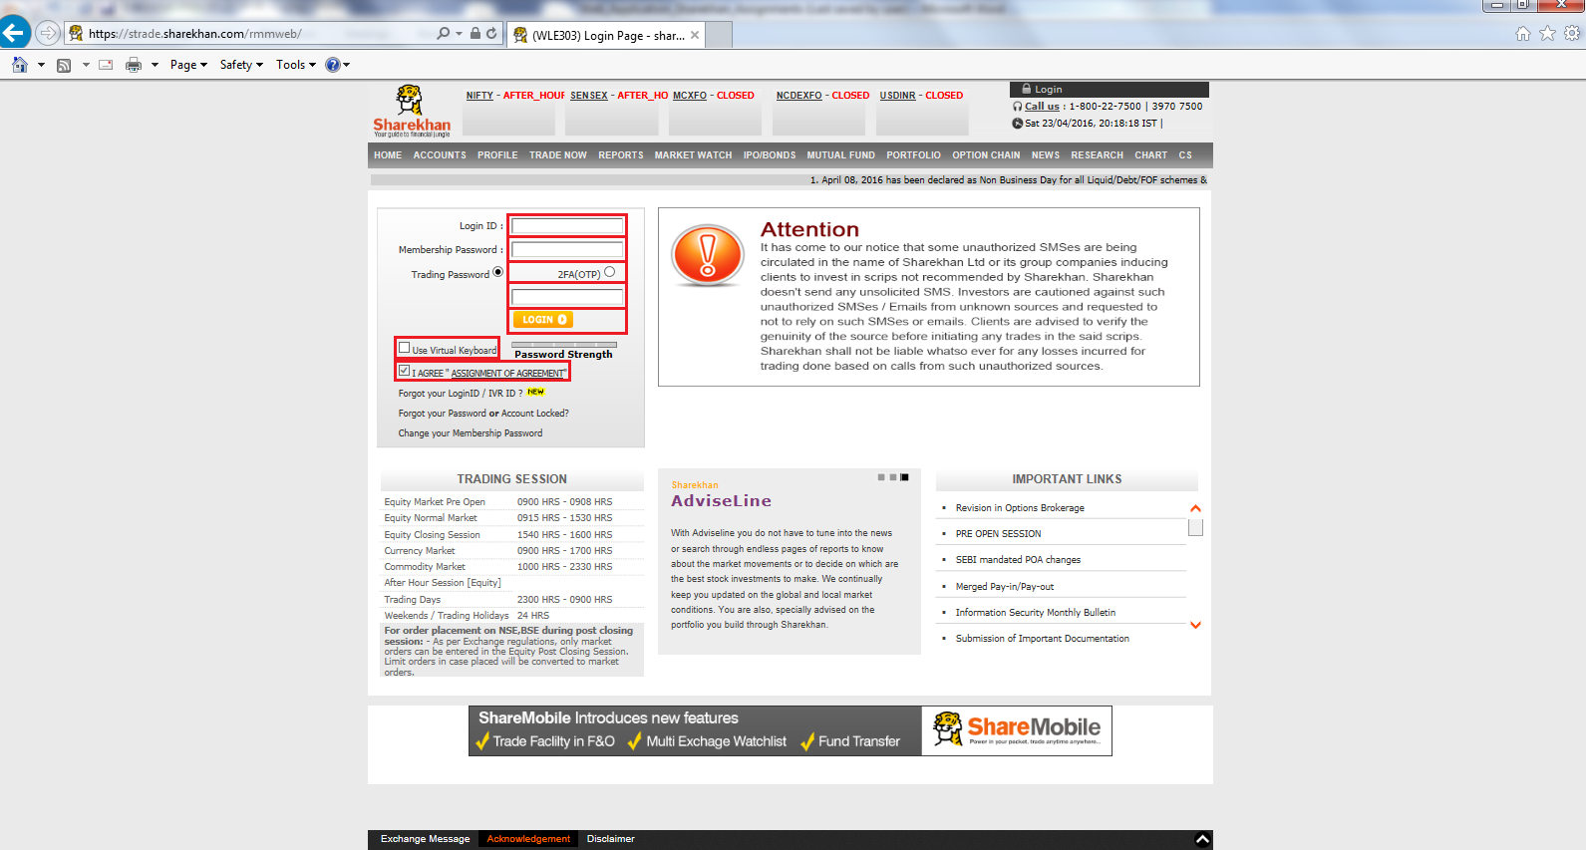

For TRADE NOW->Commodity web page(Verification- Header links like HOME, ACCOUNTS, PROFILE, TRADE NOW, REPORTS, MARKET WATCH, IPO/BONDS, MUTUAL FUND, PORTFOLIO, OPTION CHAIN, NEWS, RESEARCH, CHART, CS, Other links like "Place Order", "Order Book", "Trade Book", "Turnover Position", "UL Margin", "Limit Statement", "Order History", "Trade History", "MCX Span Margin", "NCDEX Span Margin", "MCX Bhav Copy")

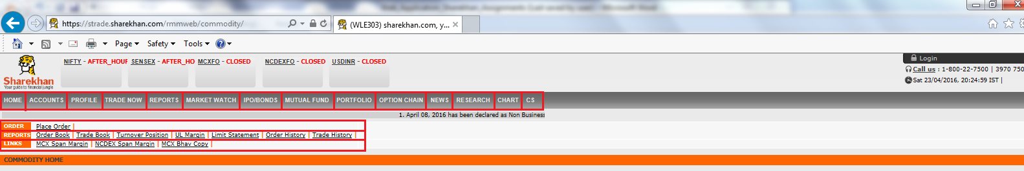

For "TRADE NOW->Mini (Low Bandwidth)" (Verification- ONLINE CUSTOMER dropdown, Text boxes like "Login ID", "Membership Password", "Trading Password", LOGIN button, Links like "Forgot Password" and "Change Password"

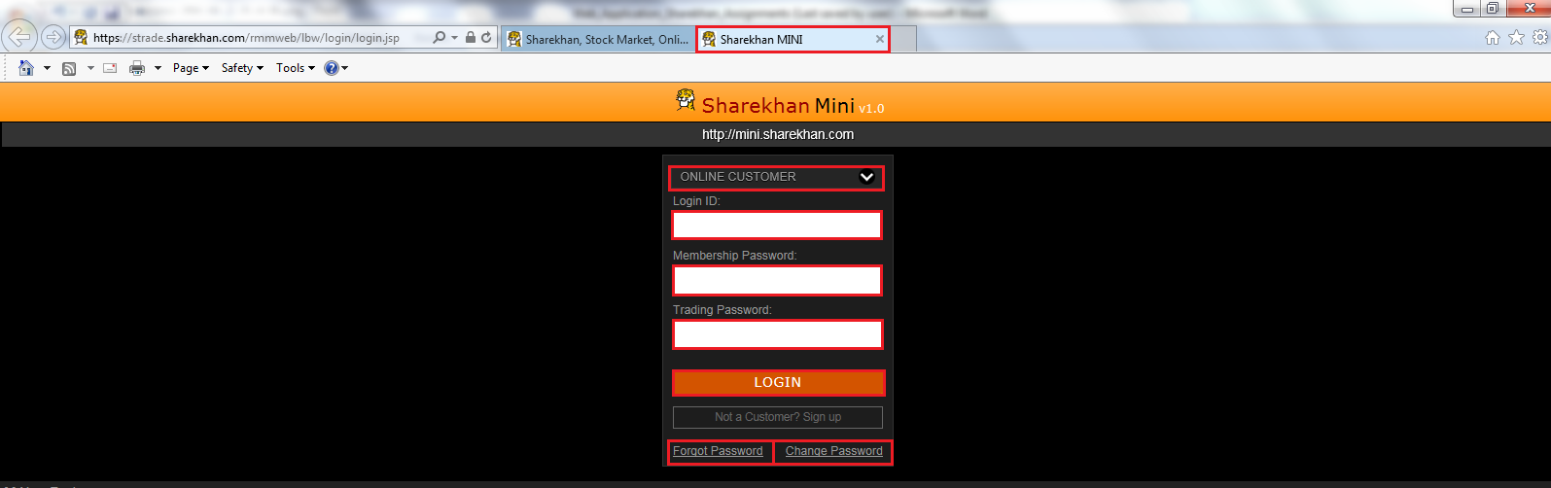

**6. To verify that when user clicks on Menu radio button like "Quotes" appropriate information is displayed on the web page**

**Steps-**

* Launch Internet Explorer
* Type www.sharekhan.com in Address bar
* Click "Visit home page" button (As shown in test case 1)
* Click radio button "Quotes".
* Enter company name e.g Axis Bank Ltd.
* Click "Go" button. Go back to previous page after verification or close the browser.

**Verification as marked in RED below-**

For Quotes radio button, a new popup should appear (Verification- Company name and its information like BSE code, NSE code & ISIN, Refresh button, tabs like NSE, BSE, FUTURES & OPTIONS with default set as NSE, Other information labels only like Current Price, Previous Close, Open, Change%, Volume, 52 Wk Hi/Lo, Day Hi/lo, Mkt Cap, Face Val and tabs like Overview, Company Info, Earnings Details, MF Holding this Script with default set to Overview)

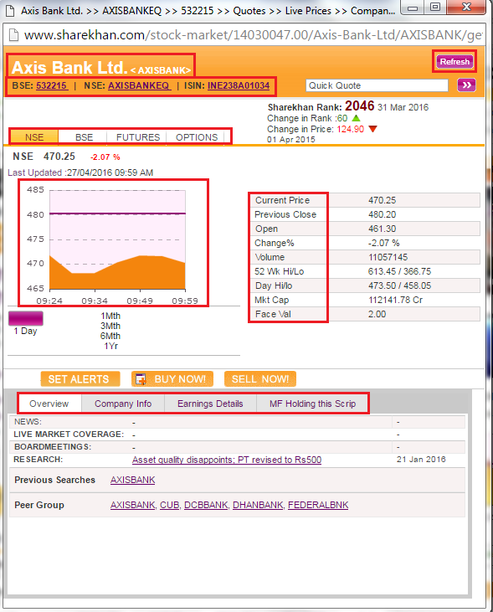

**7. To verify that when user clicks on Menu radio buttons like "NAV" appropriate information is displayed on the web page**

**Steps-**

* Launch Internet Explorer
* Type www.sharekhan.com in Address bar
* Click "Visit home page" button (As shown in test case 1)
* Click radio button "NAV".
* Enter fund name e.g SBI Blue Chip (D)
* Click "Go" button. Go back to previous page after verification or close the browser.

**Verification as marked in RED below-**

For NAV radio button, a new popup should appear (Verification- Fund name and its information like Fund type, Investment Plan, Asset Size, Last Dividend, Bonus, Min. Investment, Launch Date, Graph with default set to 1Mth, PERFORMANCE CALENDAR, PORTFOLIO, INDUSTRY WEIGHTAGE- All the data to be saved to runtime data table)

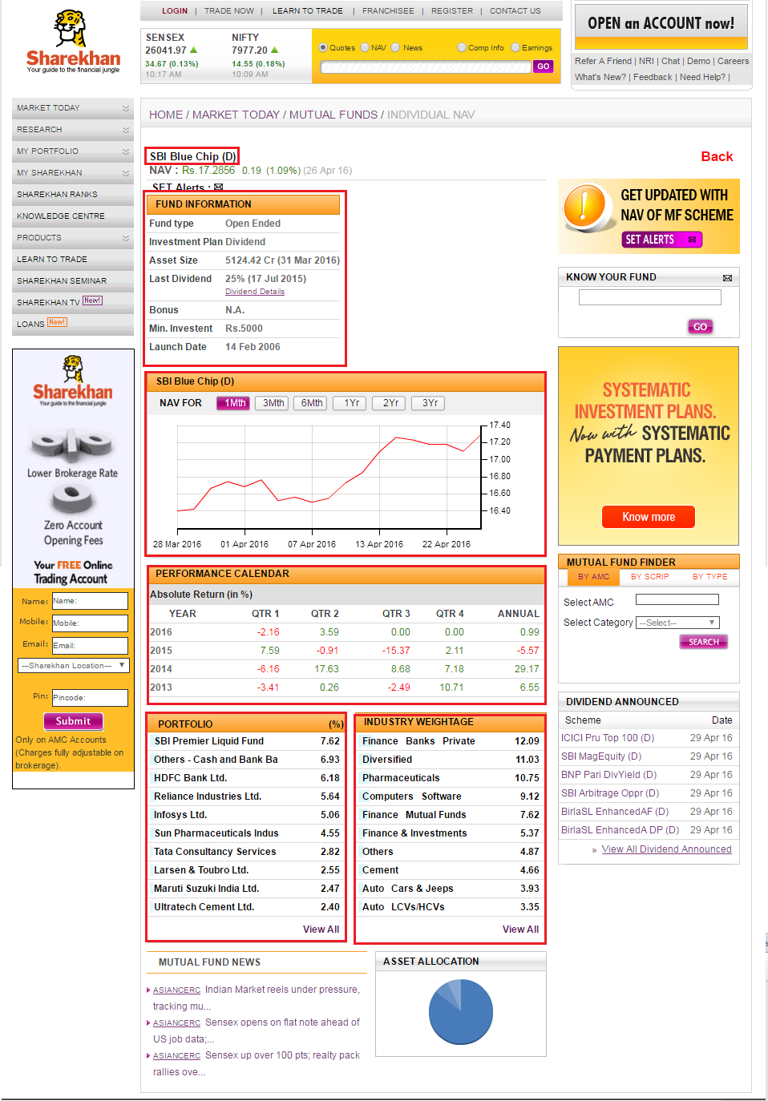

**8. To verify that when user clicks on Menu radio buttons like "News" appropriate information is displayed on the web page**

**Steps-**

* Launch Internet Explorer
* Type www.sharekhan.com in Address bar
* Click "Visit home page" button (As shown in test case 1)
* Click radio button "News".
* Enter company name e.g Infosys Ltd.
* Click "Go" button. Go back to previous page after verification or close the browser.

**Verification as marked in RED below-**

For News radio button, a new popup should appear (Verification- Company Name should appear in the News displayed, provide the news title in run time data table)

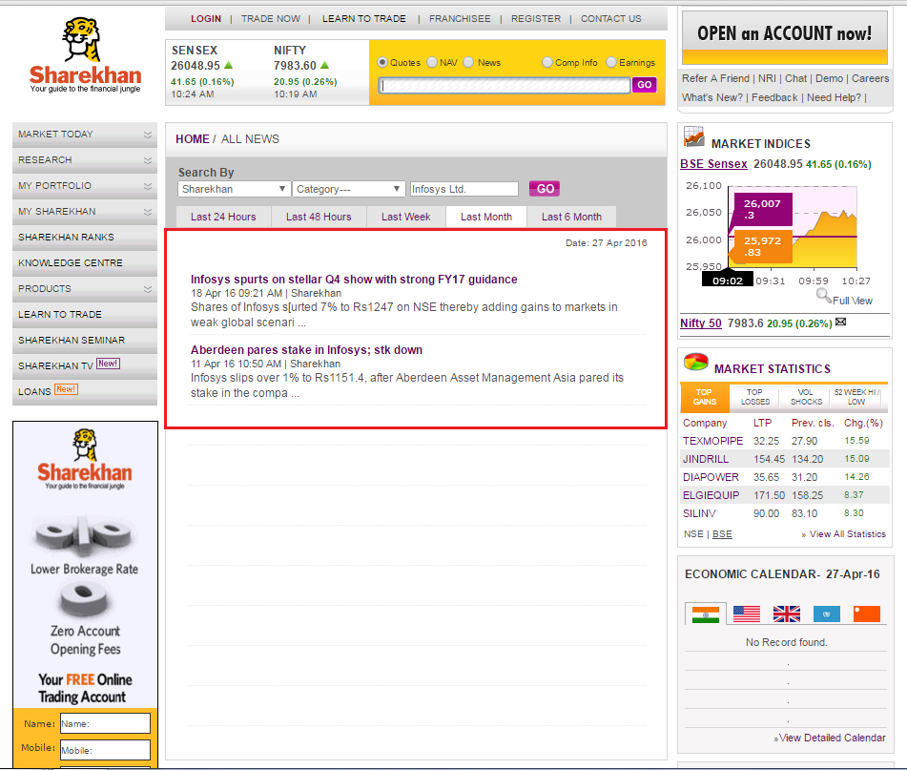

**9. To verify that when user clicks on Menu radio buttons like "Comp Info" appropriate information is displayed on the web page**

**Steps-**

* Launch Internet Explorer
* Type www.sharekhan.com in Address bar
* Click "Visit home page" button (As shown in test case 1)
* Click radio button "Comp Info".
* Enter company name e.g ICICI Bank Ltd.
* Click "Go" button. Go back to previous page after verification or close the browser.

**Verification as marked in RED below-**

For Comp Info radio button, a new popup should appear (Verification- Company Name should displayed, Tabs NSE & BSE with default set to NSE, Buttons like SET ALERTS, ADD TO WATCHLIST, ADD TO PORTFOLIO, Sections like SECTOR COMPARISON, NEWS, EARNINGS with default radio button set to Standalone, TOP MFs HOLDINGS)

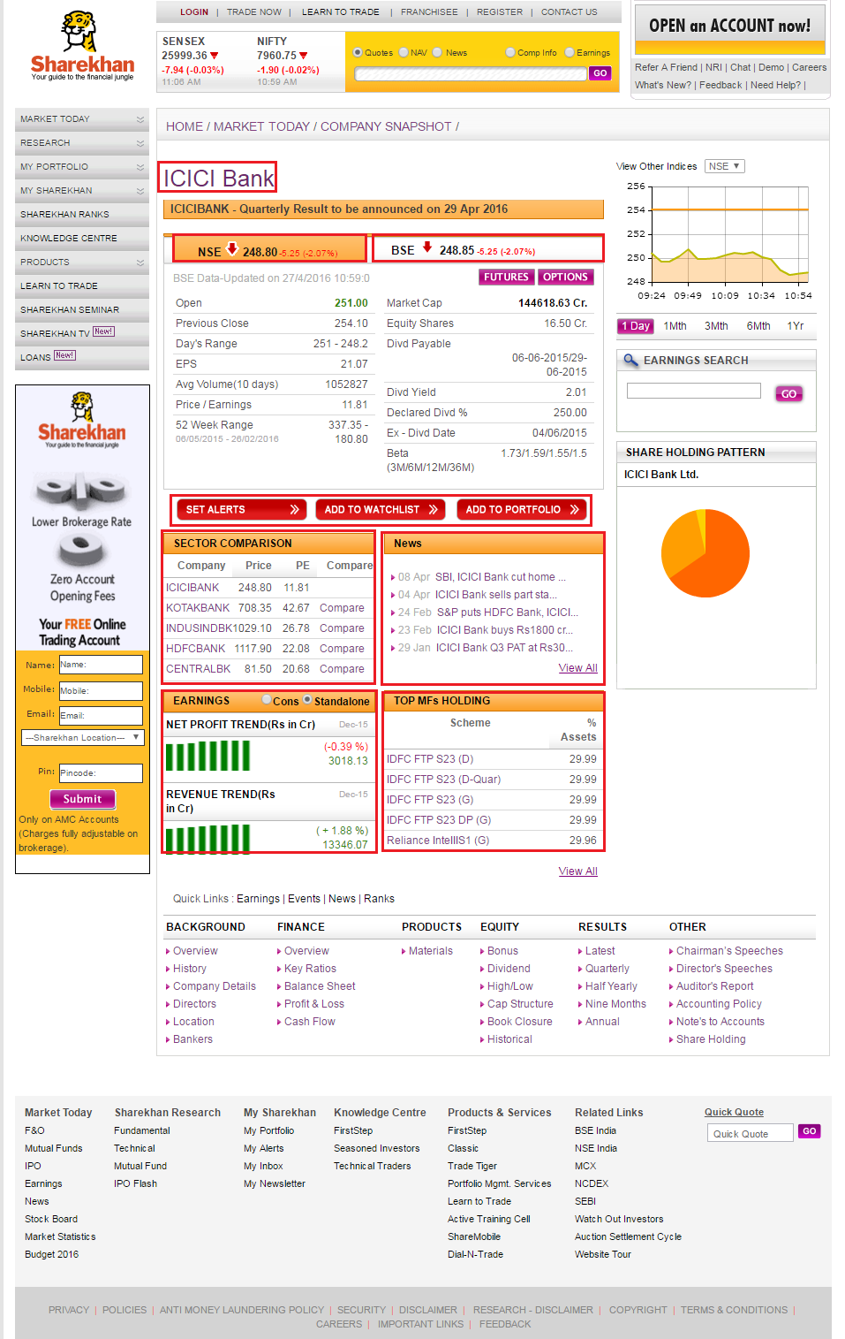

**10. To verify that when user clicks on Menu radio buttons like "Earnings" appropriate information is displayed on the web page**

**Steps-**

* Launch Internet Explorer
* Type www.sharekhan.com in Address bar
* Click "Visit home page" button (As shown in test case 1)
* Click radio button "Earnings".
* Enter company name e.g NMDC Ltd.
* Click "Go" button. Go back to previous page after verification or close the browser.

**Verification as marked in RED below-**

For Comp Info radio button, a new popup should appear (Verification- Company Name should displayed, links like Overview, Key Rations, Profit & Loss, Cash Flow, Balance Sheet, Quarterly Report, Half Yearly Report, 9 Months Report, Annual Result with default set to Quarterly Report, save the tabular data below company heading e.g. "NMDC Ltd. Standalone Quarterly Result (' in Cr) in Excel spreadhseet)

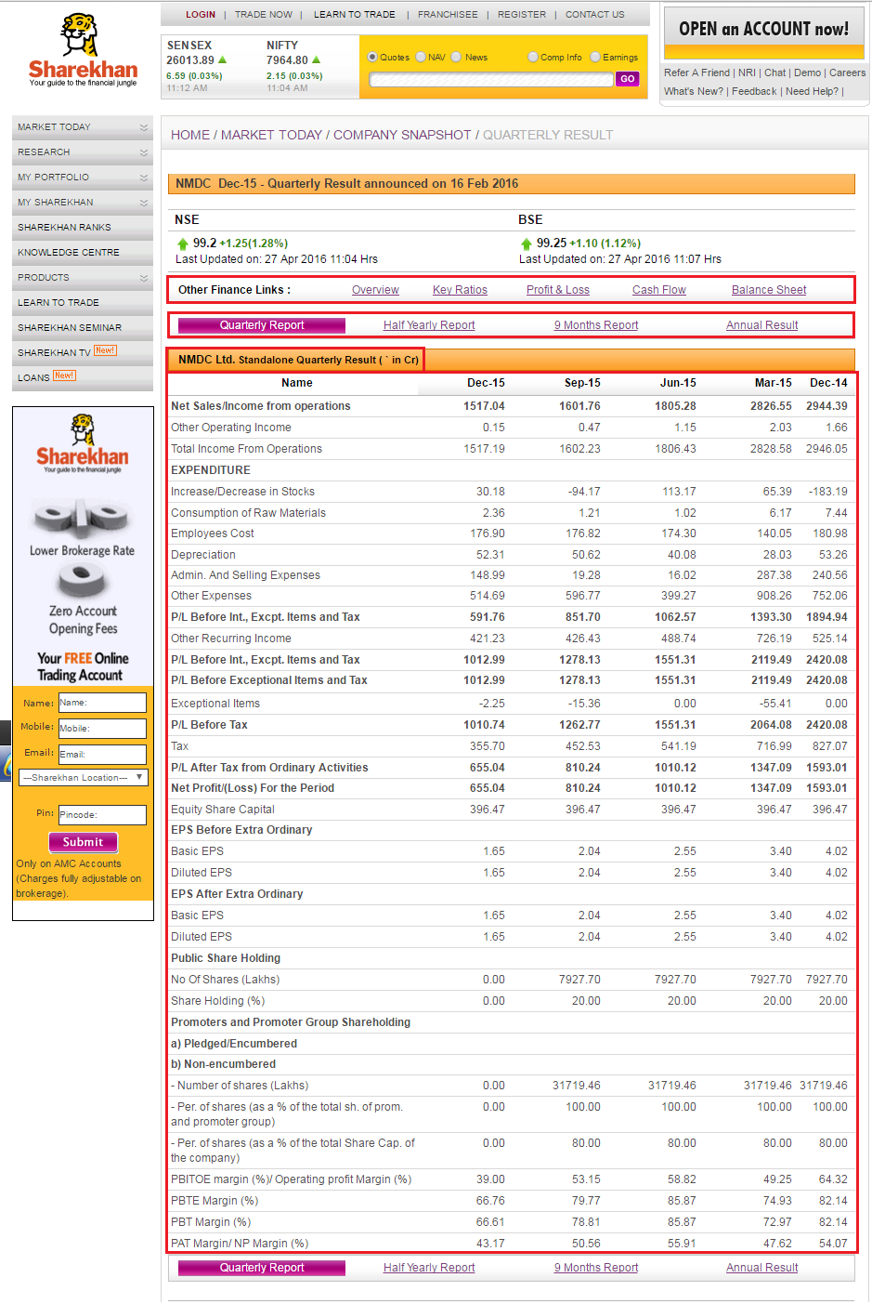

**11. To verify that expand  and collapse is working properly for all the left pane menu items like MARKET TODAY, RESEARCH, MY PORTFOLIO, MY SHAREKHAN & PRODUCTS.**

**Steps-**

* Launch Internet Explorer
* Type www.sharekhan.com in Address bar
* Click "Visit home page" button (As shown in test case 1)
* Click the expand  and collapsefor all the menu items. Close the browser when done.

** **

**Verification-**

Expand  and collapse should work for all the menu items

**12. To verify that "Download Now!" section is working.**

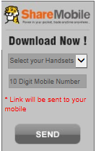

**Steps-**

* Launch Internet Explorer
* Type www.sharekhan.com in Address bar
* Click "Visit home page" button (As shown in test case 1)
* Select "Android" or "Iphone" from Select your Handsets dropdown
* Enter 10 Digit Mobile Number e.g 88888 12345
* Click "Send" button

**Verification-** Below dialog should be displayed.

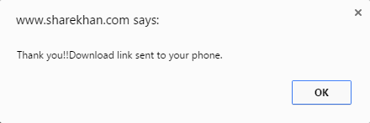

**Click "OK" button and close the web page**

**13. To verify that "Join the Club now" section is working.**

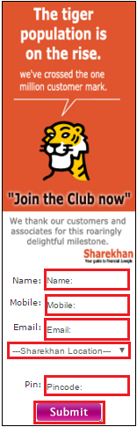

**Steps-**

* Launch Internet Explorer
* Type www.sharekhan.com in Address bar
* Click "Visit home page" button (As shown in test case 1)
* Enter Name
* Enter 10 Digit Mobile Number e.g 88888 12345
* Enter Email
* Select Sharekhan Location
* Enter Pin
* Click "Submit" button

**Verification-** Verify the default values (i.e "Name:" in Name text box, "Mobile:" in Mobile text box, "Email:" in Email text box, "---Sharekhan Location---" in dropdown, "Pincode:" in Pin text box. On Submit button click, below dialog should be displayed.

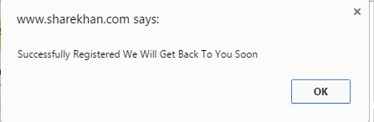

**Click "OK" button and close the web page**

14. **To verify that user is able to login when valid credentials are entered**

**Steps-**

* Launch Internet Explorer
* Type www.sharekhan.com in Address bar
* Click "Visit home page" button (As shown in test case 1)
* Click "LOGIN->Online Trading User"
* Enter valid login credentials like "Login ID", "Membership Password", "Trading Password", and select value(keep default) into "Go To" dropdown, if reqd.
* Click "Login >>" button. Logout when verification is complete

**Verification(all objects) is as marked in RED below-**

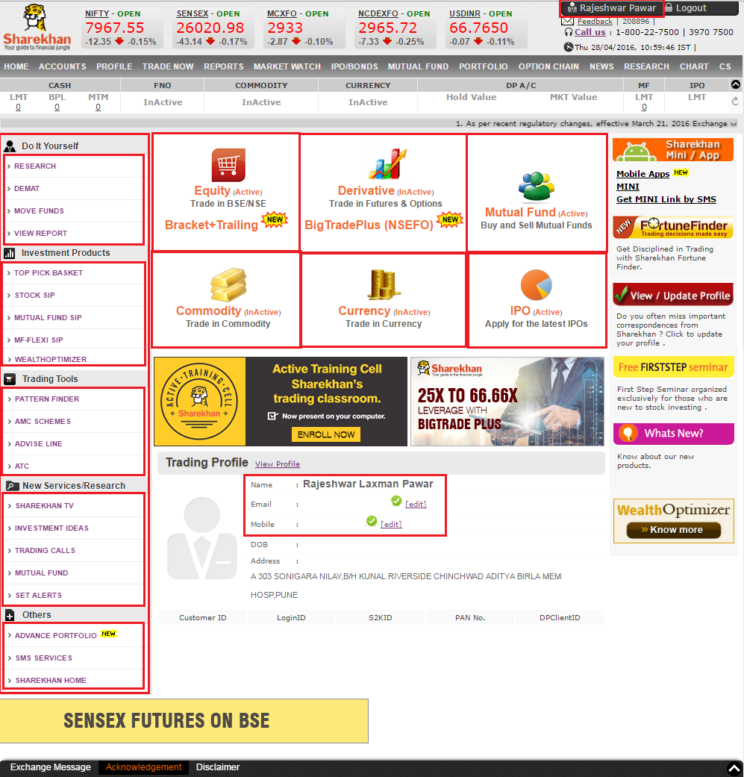

15. **To verify that when user clicks on appropriate menu name e.g Accounts corresponding page is displayed**

**Steps-**

* Launch Internet Explorer
* Type www.sharekhan.com in Address bar
* Click "Visit home page" button (As shown in test case 1)
* Click "LOGIN->Online Trading User"
* Enter valid login credentials like "Login ID", "Membership Password", "Trading Password", and select value into "Go To" dropdown, if reqd.
* Click "Login >>" button. User should be navigated to the Home page, if "Go To" dropdown is not set.
* Click ACCOUNTS in menu bar
* Logout when verification is complete

**Verification(all objects) is as marked in RED below-**

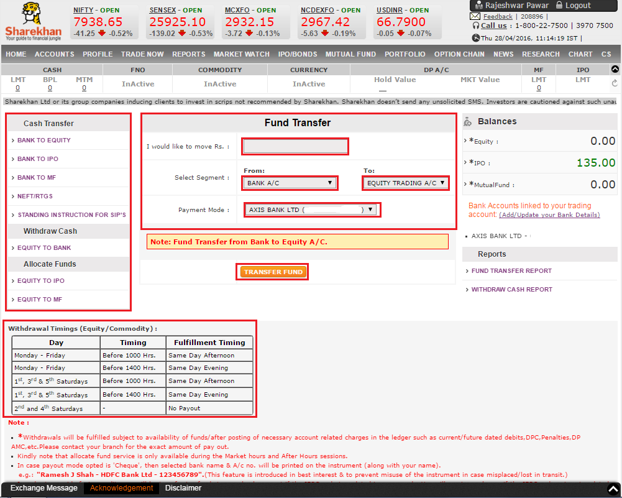

16. **To verify that when user clicks on appropriate menu name e.g Profile corresponding page is displayed**

**Steps-**

* Launch Internet Explorer
* Type www.sharekhan.com in Address bar
* Click "Visit home page" button (As shown in test case 1)
* Click "LOGIN->Online Trading User"
* Enter valid login credentials like "Login ID", "Membership Password", "Trading Password", and select value into "Go To" dropdown, if reqd.
* Click "Login >>" button. User should be navigated to the Home page, if "Go To" dropdown is not set.
* Click PROFILE in menu bar
* Logout when verification is complete

**Verification(all objects) is as marked in RED below-**

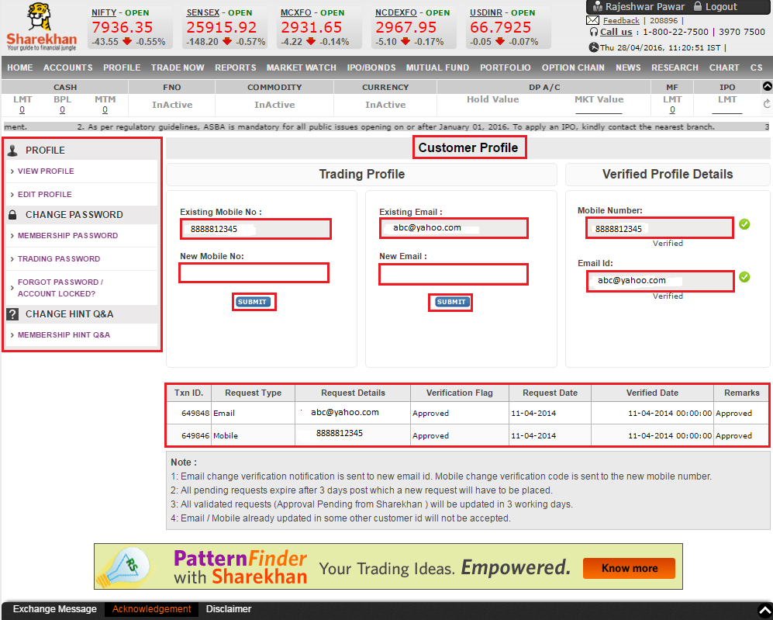

17. **To verify that when user clicks on appropriate menu name e.g Trade Now corresponding page is displayed**

**Steps-**

* Launch Internet Explorer
* Type www.sharekhan.com in Address bar
* Click "Visit home page" button (As shown in test case 1)
* Click "LOGIN->Online Trading User"
* Enter valid login credentials like "Login ID", "Membership Password", "Trading Password", and select value into "Go To" dropdown, if reqd.
* Click "Login >>" button. User should be navigated to the Home page, if "Go To" dropdown is not set.
* Click TRADE NOW in menu bar
* Logout when verification is complete

**Verification(all objects) is as marked in RED below-**

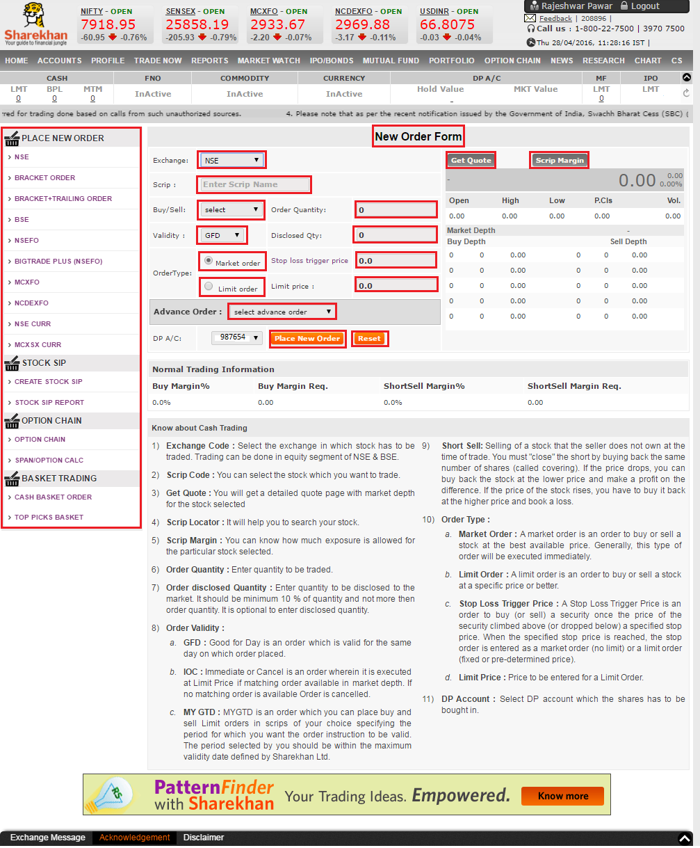

18. **To verify that when user clicks on appropriate menu name e.g Reports corresponding page is displayed**

**Steps-**

* Launch Internet Explorer
* Type www.sharekhan.com in Address bar
* Click "Visit home page" button (As shown in test case 1)
* Click "LOGIN->Online Trading User"
* Enter valid login credentials like "Login ID", "Membership Password", "Trading Password", and select value into "Go To" dropdown, if reqd.
* Click "Login >>" button. User should be navigated to the Home page, if "Go To" dropdown is not set.
* Click REPORTS in menu bar
* Logout when verification is complete

**Verification(all objects) is as marked in RED below-**

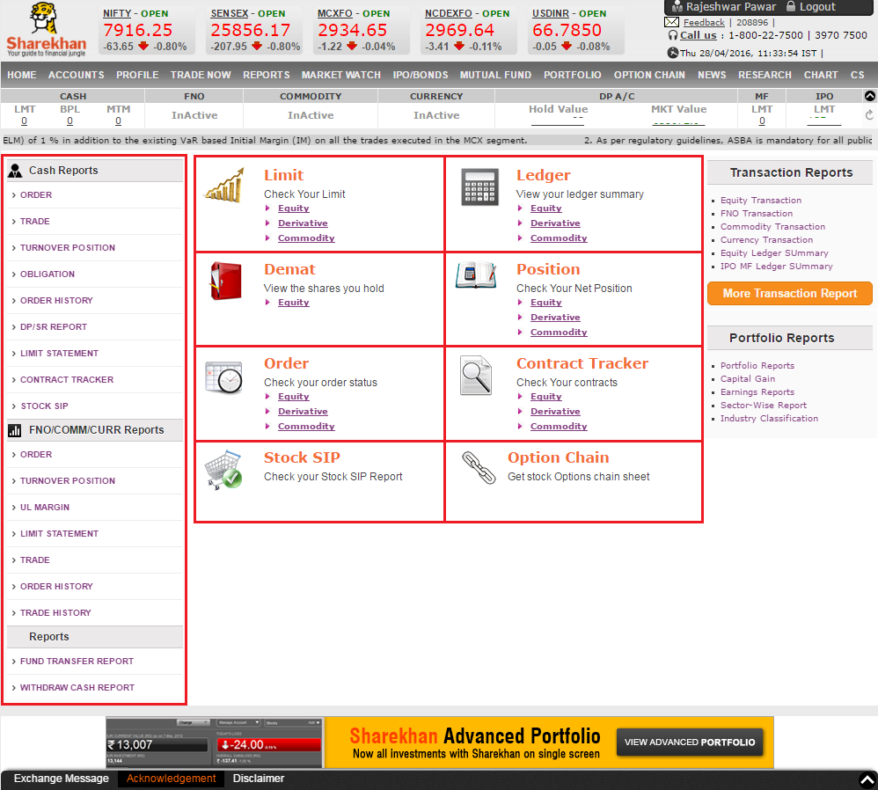

18. **To verify that when user clicks on appropriate menu name e.g Market Watch corresponding page is displayed**

**Steps-**

* Launch Internet Explorer
* Type www.sharekhan.com in Address bar
* Click "Visit home page" button (As shown in test case 1)
* Click "LOGIN->Online Trading User"
* Enter valid login credentials like "Login ID", "Membership Password", "Trading Password", and select value into "Go To" dropdown, if reqd.
* Click "Login >>" button. User should be navigated to the Home page, if "Go To" dropdown is not set.
* Click MARKET WATCH in menu bar
* Logout when verification is complete

**Verification(all objects) is as marked in RED below-**

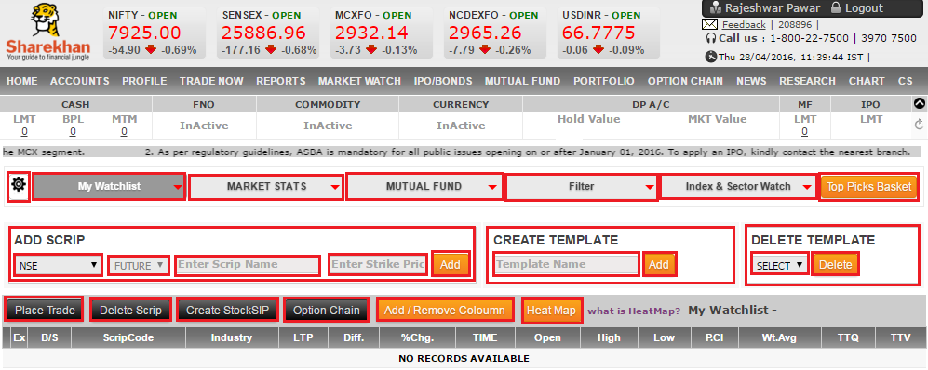

19. **To verify that when user clicks on appropriate menu name e.g IPO/Bonds corresponding page is displayed**

**Steps-**

* Launch Internet Explorer
* Type www.sharekhan.com in Address bar
* Click "Visit home page" button (As shown in test case 1)
* Click "LOGIN->Online Trading User"
* Enter valid login credentials like "Login ID", "Membership Password", "Trading Password", and select value into "Go To" dropdown, if reqd.
* Click "Login >>" button. User should be navigated to the Home page, if "Go To" dropdown is not set.
* Click IPO/BONDS in menu bar
* Logout when verification is complete

**Verification(all objects) is as marked in RED below-**

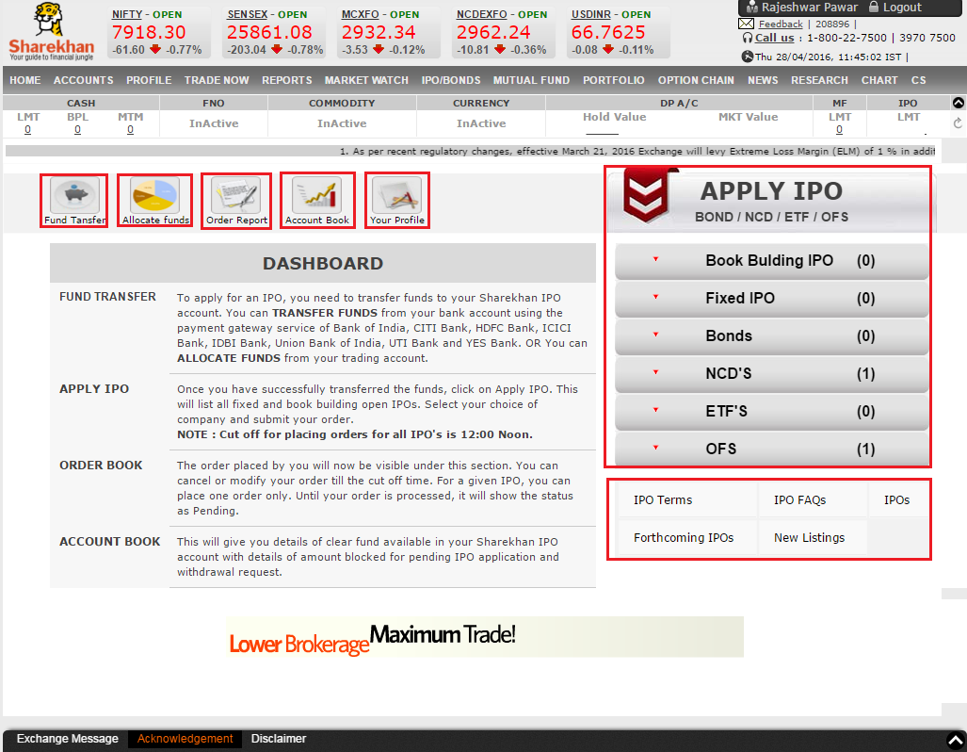

20. **To verify that when user clicks on appropriate menu name e.g Mutual Fund corresponding page is displayed**

**Steps-**

* Launch Internet Explorer
* Type www.sharekhan.com in Address bar
* Click "Visit home page" button (As shown in test case 1)
* Click "LOGIN->Online Trading User"
* Enter valid login credentials like "Login ID", "Membership Password", "Trading Password", and select value into "Go To" dropdown, if reqd.
* Click "Login >>" button. User should be navigated to the Home page, if "Go To" dropdown is not set.
* Click MUTUAL FUND in menu bar
* Logout when verification is complete

**Verification(all objects) is as marked in RED below-**

21. **To verify that when user clicks on appropriate menu name e.g Portfolio corresponding page is displayed**

**Steps-**

* Launch Internet Explorer
* Type www.sharekhan.com in Address bar
* Click "Visit home page" button (As shown in test case 1)
* Click "LOGIN->Online Trading User"
* Enter valid login credentials like "Login ID", "Membership Password", "Trading Password", and select value into "Go To" dropdown, if reqd.
* Click "Login >>" button. User should be navigated to the Home page, if "Go To" dropdown is not set.
* Click PORTFOLIO in menu bar
* Logout when verification is complete

**Verification(all objects) is as marked in RED below-**

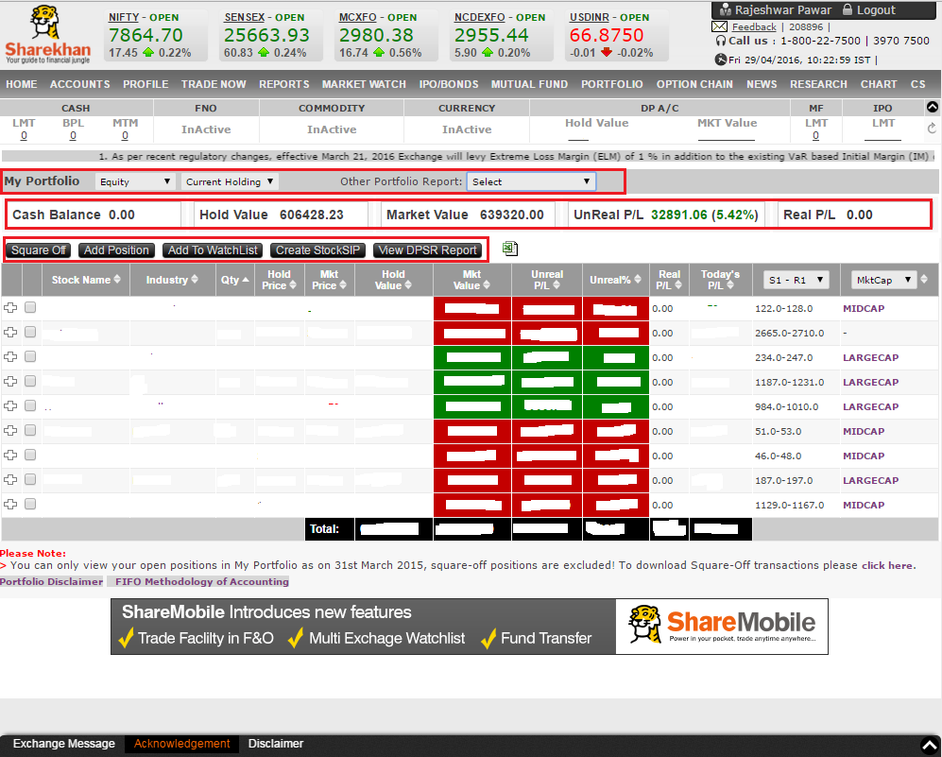

22. **To verify that when user clicks on appropriate menu name e.g Option Chain corresponding page is displayed**

**Steps-**

* Launch Internet Explorer
* Type www.sharekhan.com in Address bar
* Click "Visit home page" button (As shown in test case 1)
* Click "LOGIN->Online Trading User"
* Enter valid login credentials like "Login ID", "Membership Password", "Trading Password", and select value into "Go To" dropdown, if reqd.
* Click "Login >>" button. User should be navigated to the Home page, if "Go To" dropdown is not set.
* Click OPTION CHAIN in menu bar
* Logout when verification is complete

**Verification(all objects) is as marked in RED below-**

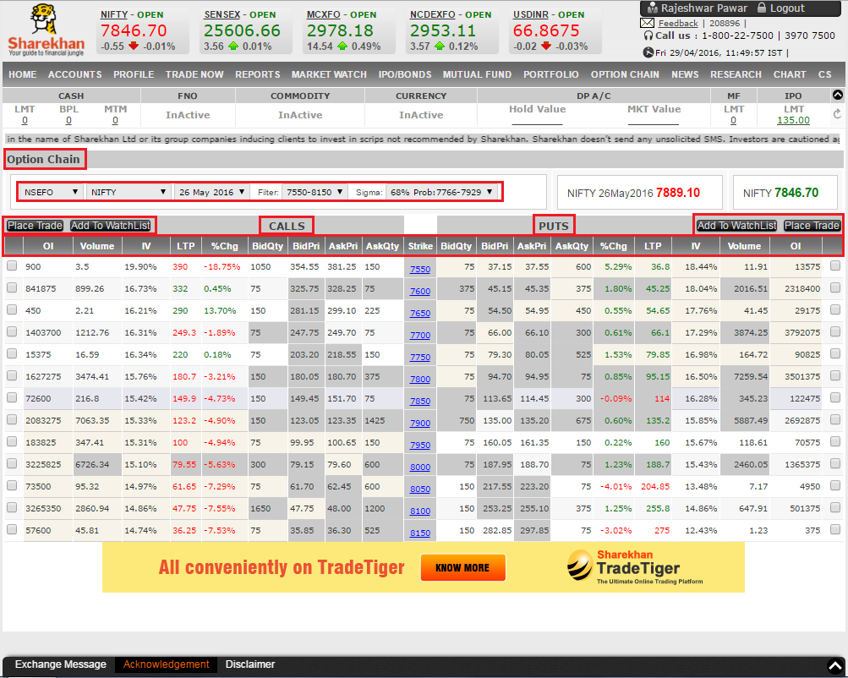

23. **To verify that when user clicks on appropriate menu name e.g News corresponding page is displayed**

**Steps-**

* Launch Internet Explorer
* Type www.sharekhan.com in Address bar
* Click "Visit home page" button (As shown in test case 1)
* Click "LOGIN->Online Trading User"
* Enter valid login credentials like "Login ID", "Membership Password", "Trading Password", and select value into "Go To" dropdown, if reqd.
* Click "Login >>" button. User should be navigated to the Home page, if "Go To" dropdown is not set.
* Click NEWS in menu bar
* Logout when verification is complete

**Verification(all objects) is as marked in RED below-**

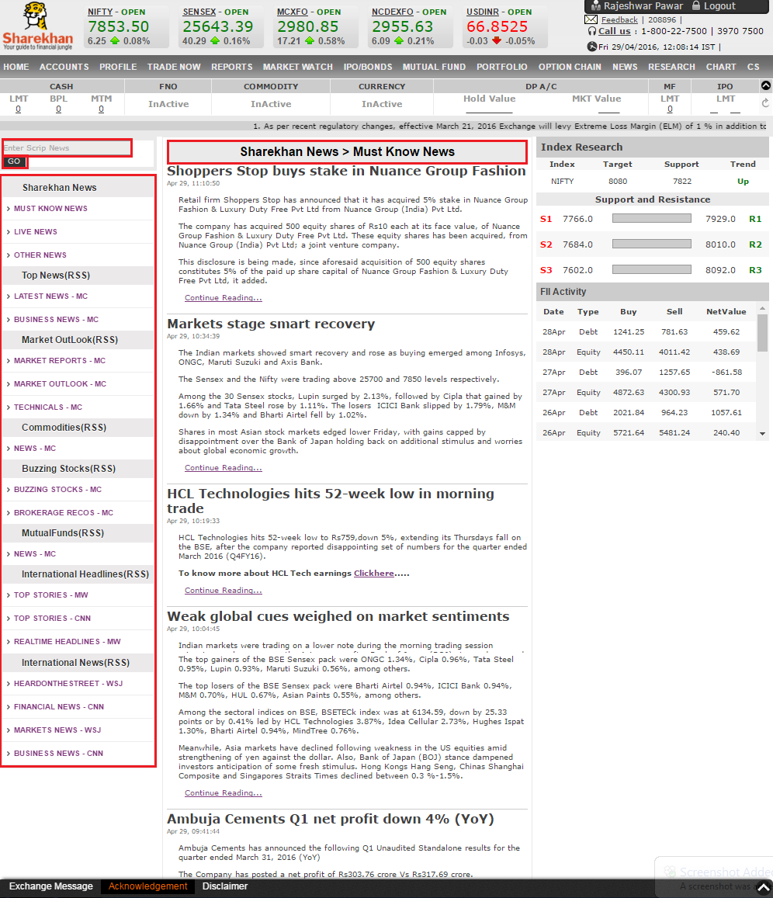

24. **To verify that when user clicks on appropriate menu name e.g Research corresponding page is displayed**

**Steps-**

* Launch Internet Explorer
* Type www.sharekhan.com in Address bar
* Click "Visit home page" button (As shown in test case 1)
* Click "LOGIN->Online Trading User"
* Enter valid login credentials like "Login ID", "Membership Password", "Trading Password", and select value into "Go To" dropdown, if reqd.
* Click "Login >>" button. User should be navigated to the Home page, if "Go To" dropdown is not set.
* Click RESEARCH in menu bar
* Logout when verification is complete

**Verification(all objects) is as marked in RED below-**

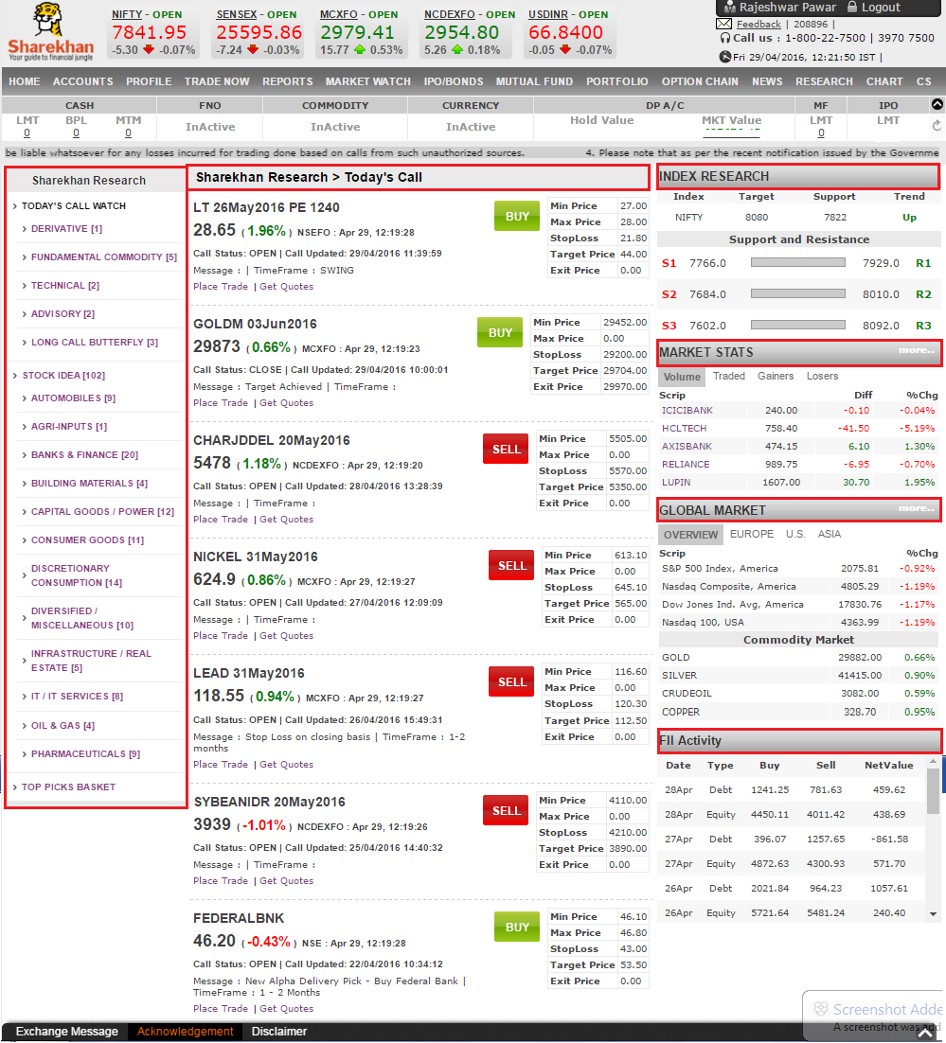

25. **To verify that when user clicks on appropriate menu name e.g Chart corresponding page is displayed**

**Steps-**

* Launch Internet Explorer
* Type www.sharekhan.com in Address bar
* Click "Visit home page" button (As shown in test case 1)
* Click "LOGIN->Online Trading User"
* Enter valid login credentials like "Login ID", "Membership Password", "Trading Password", and select value into "Go To" dropdown, if reqd.
* Click "Login >>" button. User should be navigated to the Home page, if "Go To" dropdown is not set.
* Click CHART in menu bar
* Logout when verification is complete

**Verification(all objects) is as marked in RED below-**

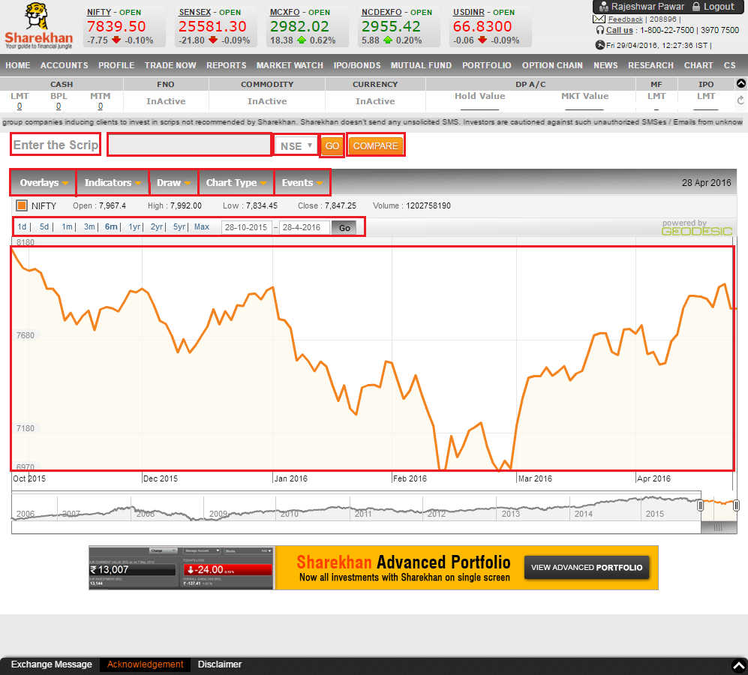

26. **To verify that when user clicks on appropriate menu name e.g CS corresponding page is displayed**

**Steps-**

* Launch Internet Explorer
* Type www.sharekhan.com in Address bar
* Click "Visit home page" button (As shown in test case 1)
* Click "LOGIN->Online Trading User"
* Enter valid login credentials like "Login ID", "Membership Password", "Trading Password", and select value into "Go To" dropdown, if reqd.
* Click "Login >>" button. User should be navigated to the Home page, if "Go To" dropdown is not set.
* Click CS in menu bar
* Logout when verification is complete

**Verification(all objects) is as marked in RED below-**

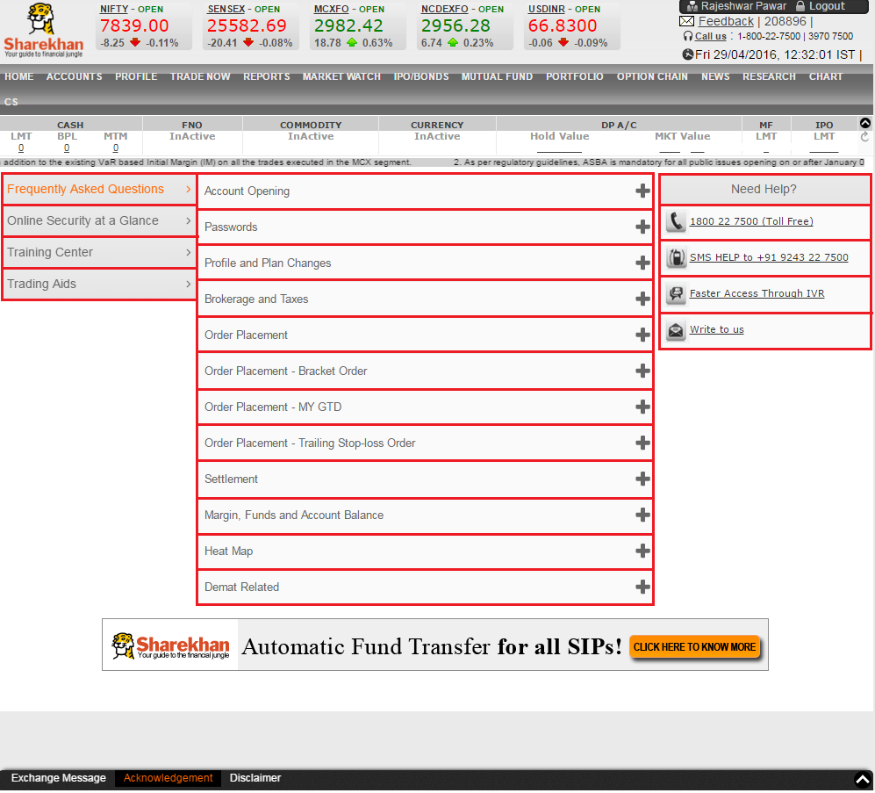

27. **To verify that user clicks on HOME->Equity (Active) icon, Equity->New Order web page is launched**

**Steps-**

* Launch Internet Explorer
* Type www.sharekhan.com in Address bar
* Click "Visit home page" button (As shown in test case 1)
* Click "LOGIN->Online Trading User"
* Enter valid login credentials like "Login ID", "Membership Password", "Trading Password", and select value into "Go To" dropdown, if reqd.
* Click "Login >>" button. User is navigated to appropriate home page as below-

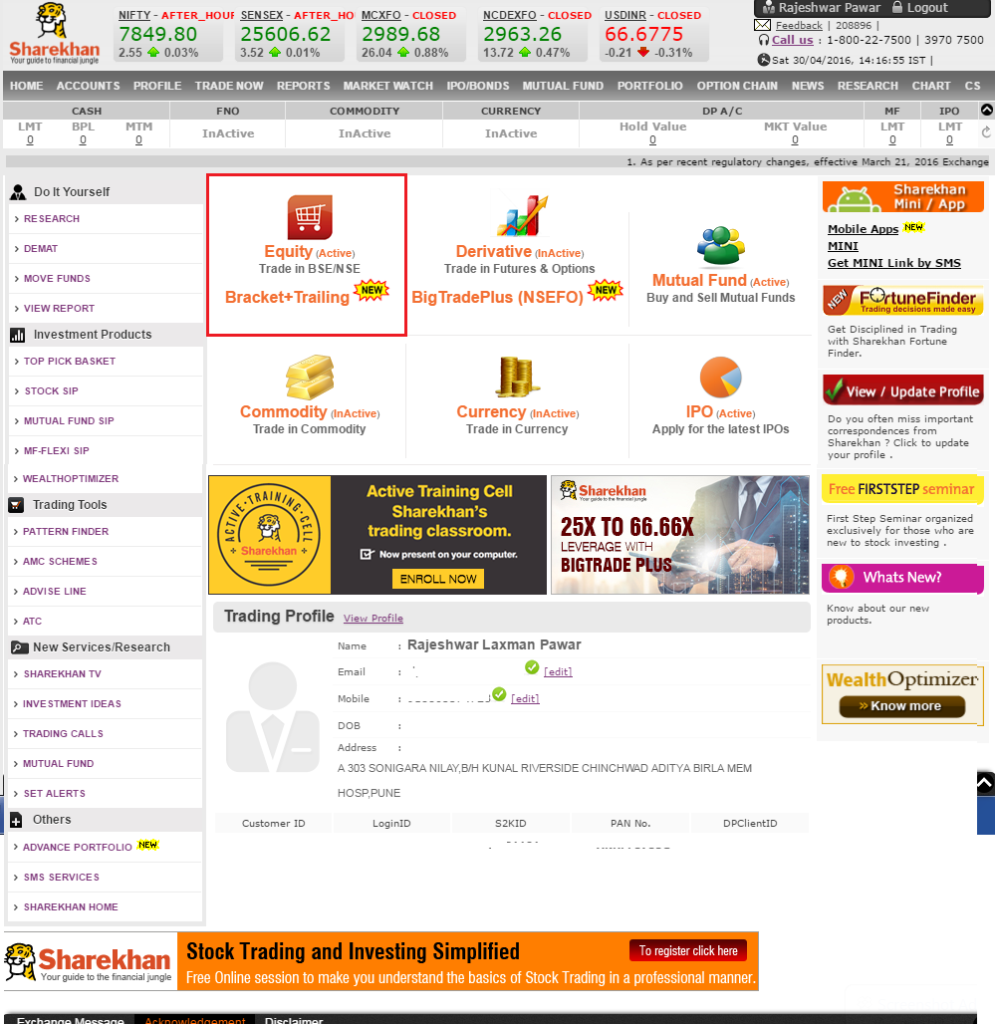

* Click Equity (Active) icon as marked in RED above. User should be navigated to web page below.

**Verification(all objects) is as marked in RED below-**



* Logout when verification is complete

28. **To verify that user clicks on HOME->Mutual Fund (Active) icon, Mutual Fund->New Order web page is launched**

**Steps-**

* Launch Internet Explorer
* Type www.sharekhan.com in Address bar
* Click "Visit home page" button (As shown in test case 1)
* Click "LOGIN->Online Trading User"
* Enter valid login credentials like "Login ID", "Membership Password", "Trading Password", and select value into "Go To" dropdown, if reqd.
* Click "Login >>" button. User is navigated to appropriate home page as below-

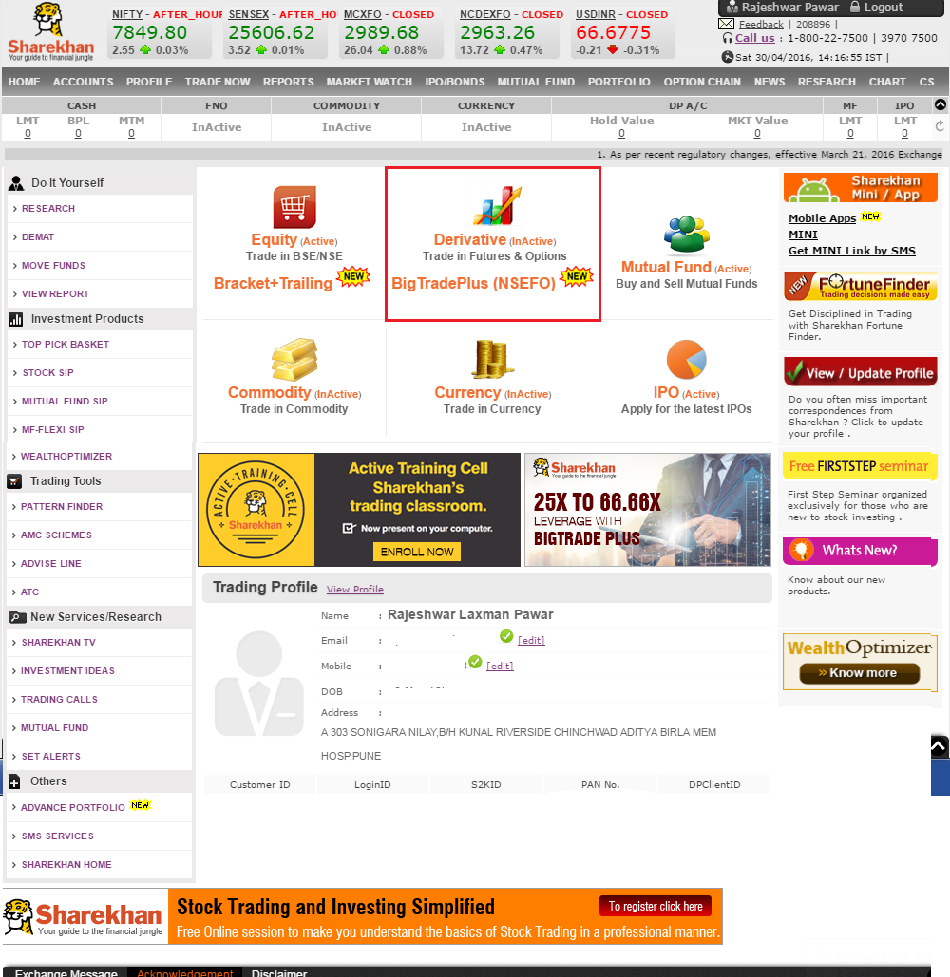

* Click Mutual Fund (Active) icon as marked in RED above. User should be navigated to web page below.

**Verification(all objects) is as marked in RED below-**

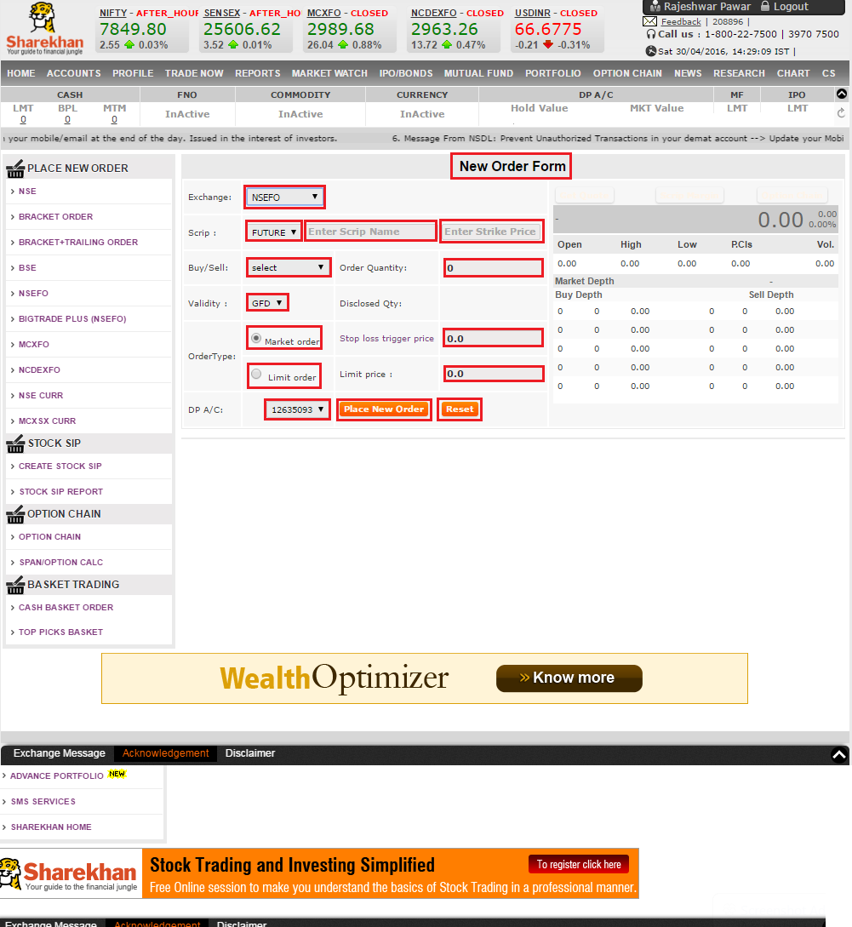

* Logout when verification is complete

29. **To verify that user clicks on HOME->IPO (Active) icon, IPO->New Order web page is launched**

**Steps-**

* Launch Internet Explorer
* Type www.sharekhan.com in Address bar
* Click "Visit home page" button (As shown in test case 1)
* Click "LOGIN->Online Trading User"
* Enter valid login credentials like "Login ID", "Membership Password", "Trading Password", and select value into "Go To" dropdown, if reqd.
* Click "Login >>" button. User is navigated to appropriate home page as below-

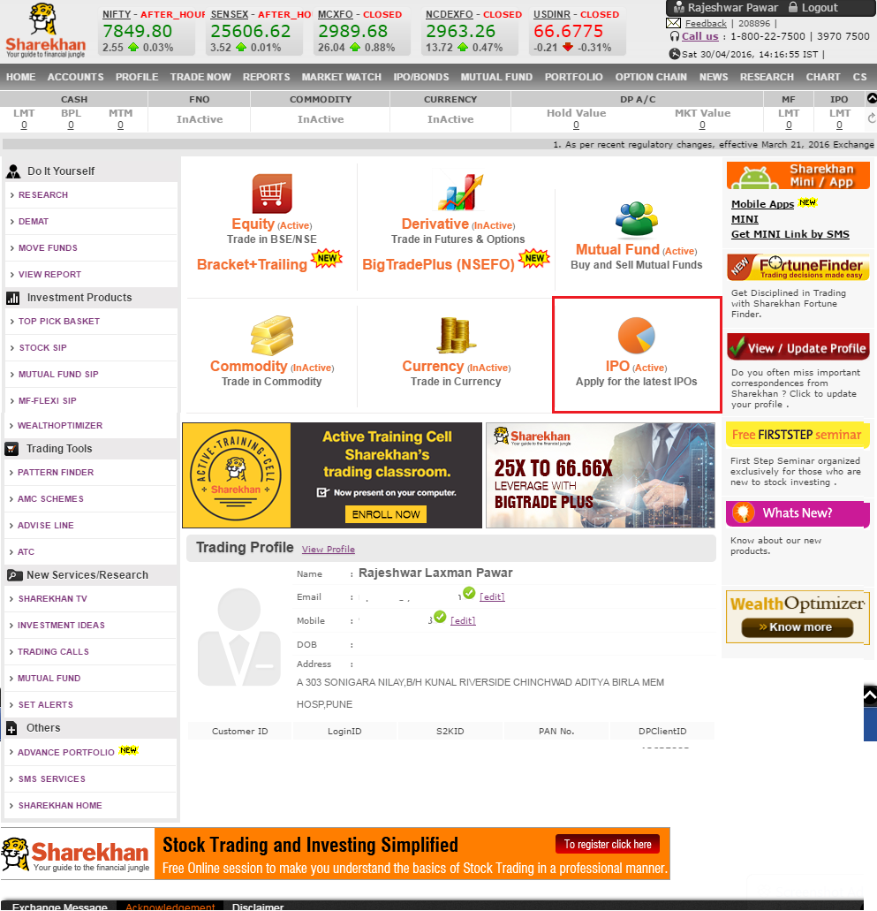

* Click IPO (Active) icon as marked in RED above. User should be navigated to web page below.

**Verification(all objects) is as marked in RED below-**



30. **To verify that user is able to transfer the funds between the various accounts i.e Bank to Equity, Mutual Fund, IPO and vice versa**

**Steps-**

* Launch Internet Explorer
* Type www.sharekhan.com in Address bar
* Click "Visit home page" button (As shown in test case 1)
* Click "LOGIN->Online Trading User"
* Enter valid login credentials like "Login ID", "Membership Password", "Trading Password", and select value into "Go To" dropdown, if reqd.
* Click "Login >>" button. User should be navigated to the Home page, if "Go To" dropdown is not set.
* Click ACCOUNTS in menu bar. Below web page should be displayed.

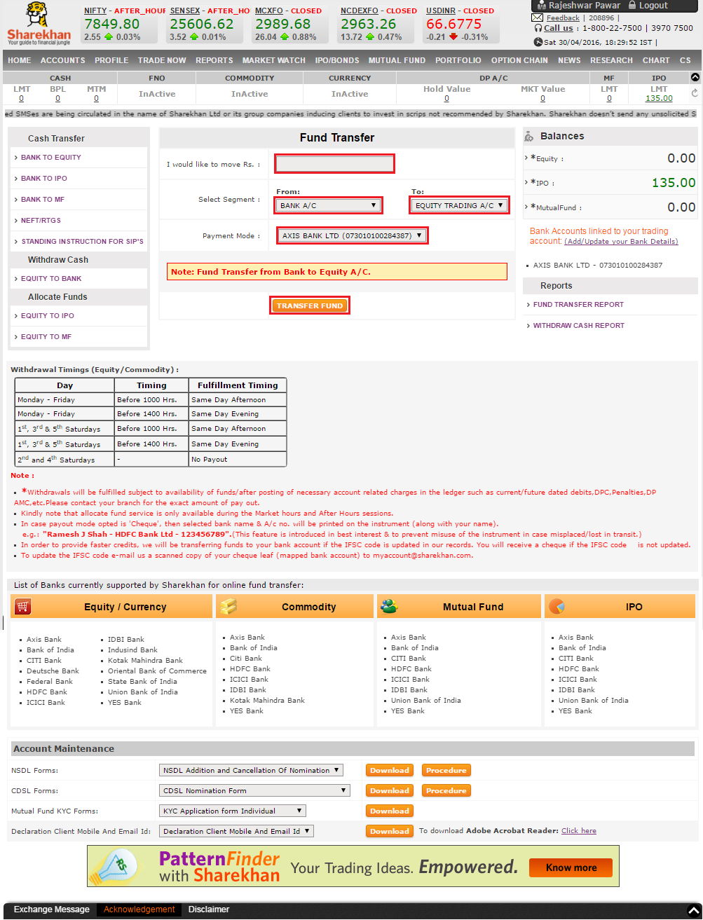

* Enter the amount to transfer, Select the segment i.e From & To, Payment mode.
* Click TRANSFER FUND. Below dialog box should be displayed-

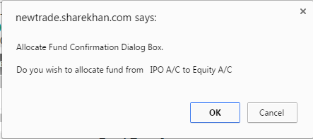

* Click OK button. The funds should be transfered

**Verification(all objects) is as marked in RED below-**

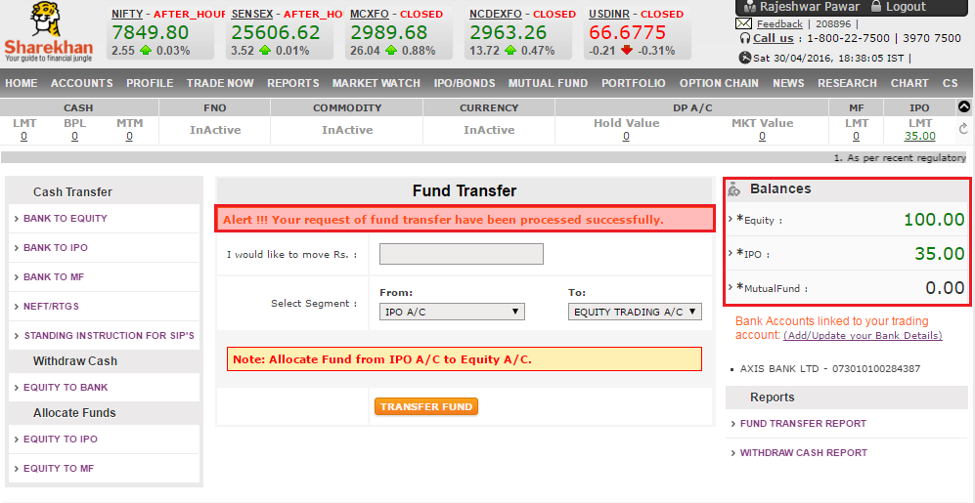

* Logout when verification is complete

31. **To verify that user is able to login when valid credentials are entered and landed to "Trade Now" page**

**Steps-**

* Launch Internet Explorer
* Type www.sharekhan.com in Address bar
* Click "Visit home page" button (As shown in test case 1)
* Click "LOGIN->Online Trading User"
* Enter valid login credentials like "Login ID", "Membership Password", "Trading Password", and select value(as Trade Now) into "Go To" dropdown, if reqd.
* Click "Login >>" button. Logout when verification is complete

**Verification(all objects) is as marked in RED below-**



32. **To verify that user is able to login when valid credentials are entered and landed to "Sharekhan Home" page**

**Steps-**

* Launch Internet Explorer
* Type www.sharekhan.com in Address bar
* Click "Visit home page" button (As shown in test case 1)
* Click "LOGIN->Online Trading User"
* Enter valid login credentials like "Login ID", "Membership Password", "Trading Password", and select value(as Sharekhan Home) into "Go To" dropdown, if reqd.
* Click "Login >>" button. Logout when verification is complete

**Verification(all objects) is as marked in RED below-**



33. **To verify that user is able to login when valid credentials are entered and landed to "My Portfolio" page**

**Steps-**

* Launch Internet Explorer
* Type www.sharekhan.com in Address bar
* Click "Visit home page" button (As shown in test case 1)
* Click "LOGIN->Online Trading User"
* Enter valid login credentials like "Login ID", "Membership Password", "Trading Password", and select value(as My Portfolio) into "Go To" dropdown, if reqd.
* Click "Login >>" button. Logout when verification is complete

**Verification(all objects) is as marked in RED below-**

